Install MySQL

## **Download MySQL Installer**

If you want to install MySQL on the Windows environment, using MySQL installer is the easiest way. MySQL installer provides you with an easy-to-use wizard that helps you to install MySQL with the following components:

* MySQL Server
* All Available Connectors
* MySQL Workbench with Sample Data Models
* MySQL Notifier
* Tools for Excel and Microsoft Visual Studio
* MySQL Sample Databases
* MySQL Documentation

To download MySQL installer, go to the following link <http://dev.mysql.com/downloads/installer/>.  There are two installer files:

* If you are connecting to the internet while installing MySQL, you can choose the online installation version  mysql-installer-web-community-<version>.exe .
* In case you want to install MySQL offline, you can download the  mysql-installer-community-<version>.exe  file.

## **Install MySQL via MySQL Installer**

To install MySQL using the MySQL installer, double-click on the MySQL installer file and follow the steps below:

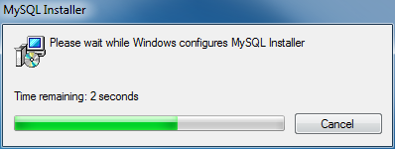  
Install MySQL Step 1: Windows configures MySQL Installer

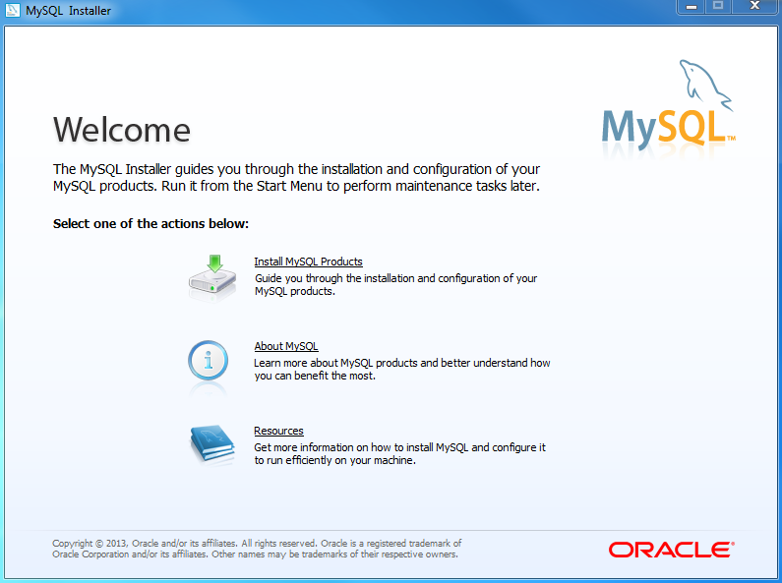  
Install MySQL Step 2 – Welcome Screen: A welcome screen provides several options. Choose the first option: Install MySQL Products

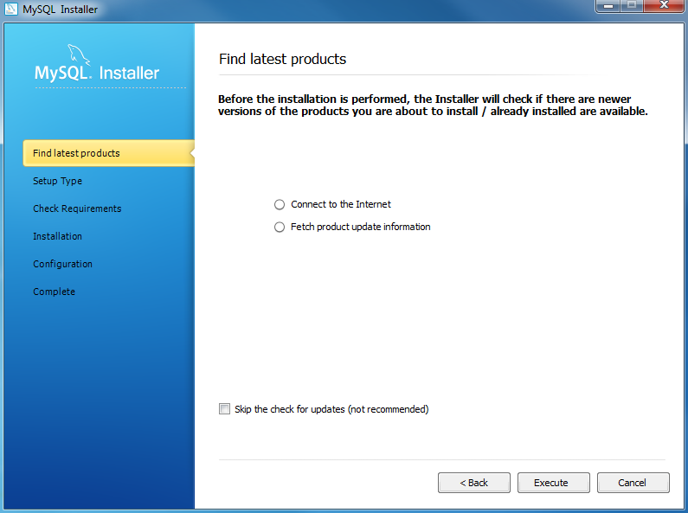  
Install MySQL Step 3 – Download the latest MySQL products: MySQL installer checks and downloads the latest MySQL products including MySQL server, MySQL Workbench, etc.

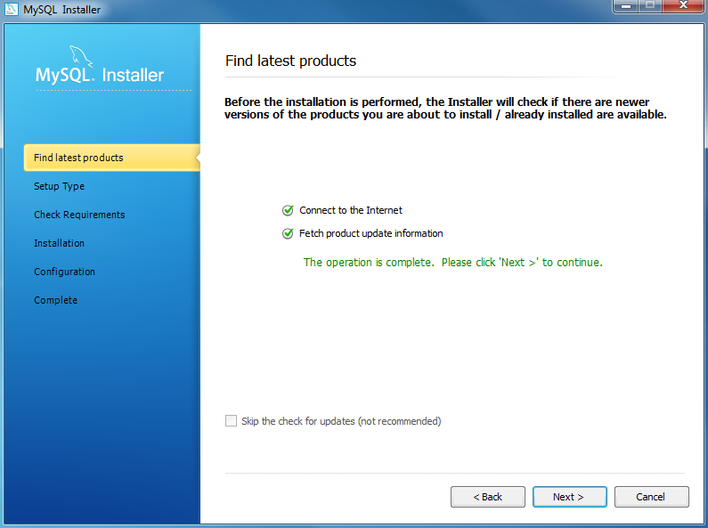  
Install MySQL Step 4: Click the Next button to continue

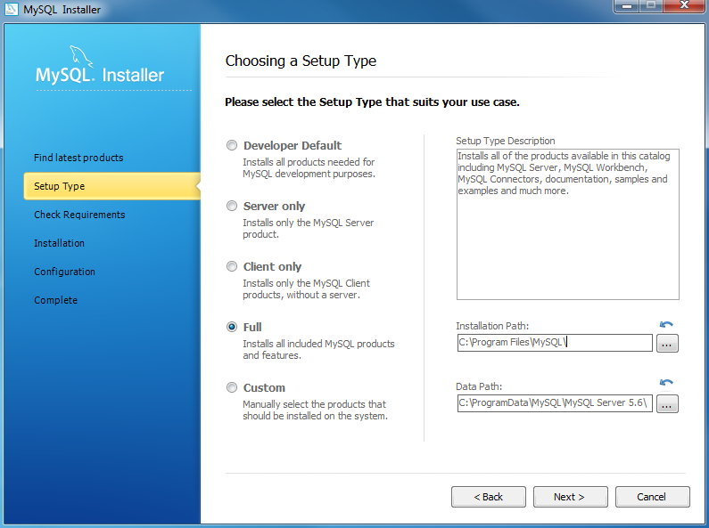  
Install MySQL Step 5 – Choosing a Setup Type: there are several setup types available. Choose the Full option to install all MySQL products and features.

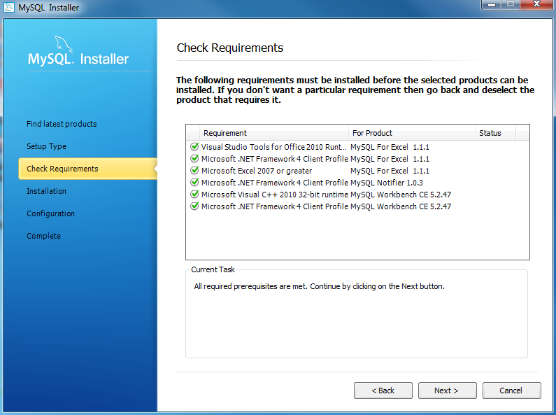  
Install MySQL Step 6 – Checking Requirements

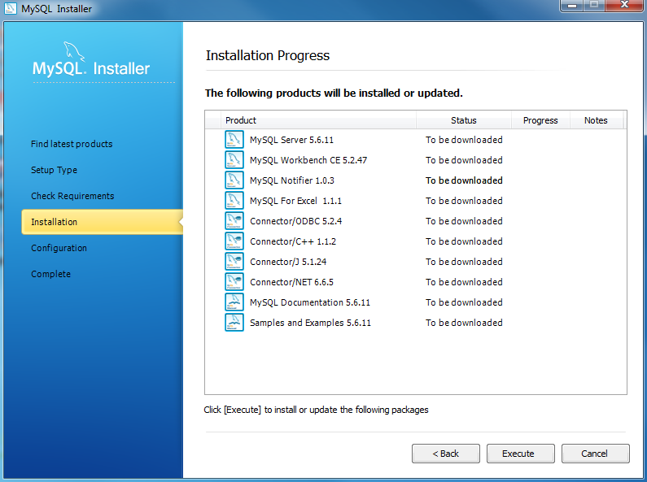  
Install MySQL Step 7 – Installation Progress: MySQL Installer downloads all selected products. It will take a while, depending on which products you selected and the speed of your internet connection.

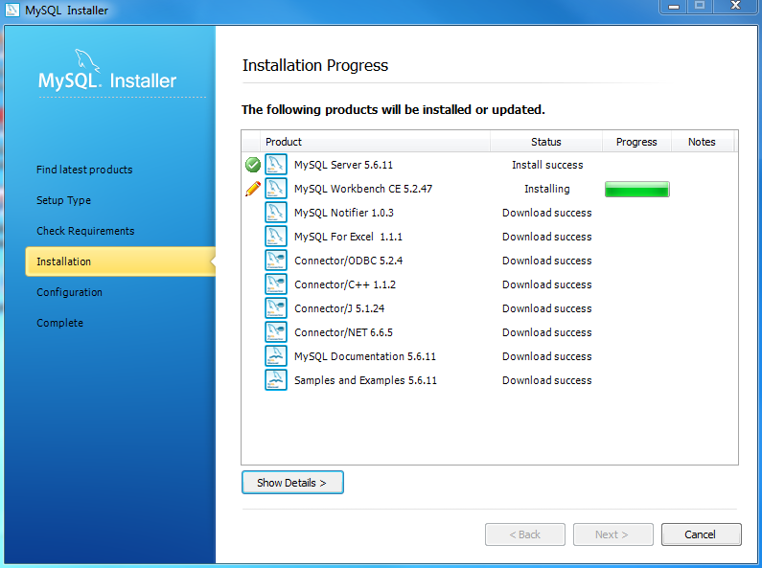  
Install MySQL Step 7 – Installation Progress: downloading Products in progress.

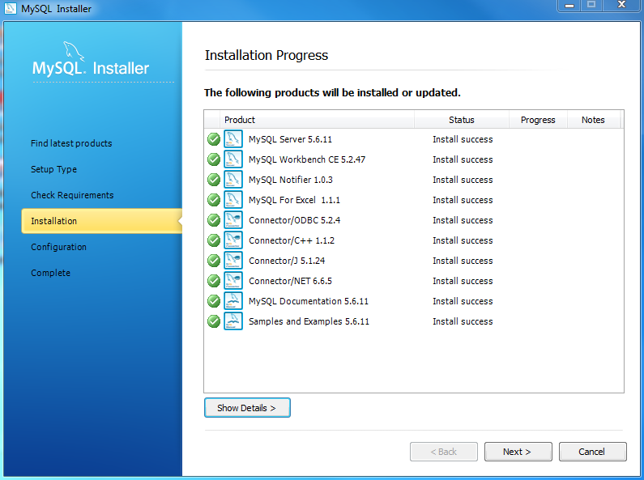  
Install MySQL Step 7 – Installation Progress: Complete Downloading. Click the **Next** button to continue…

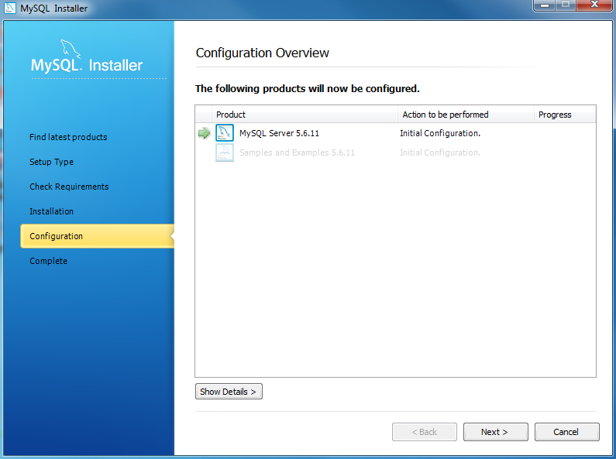

Install MySQL Step 8 – Configuration Overview. Click the Next button to configure MySQL Database Server

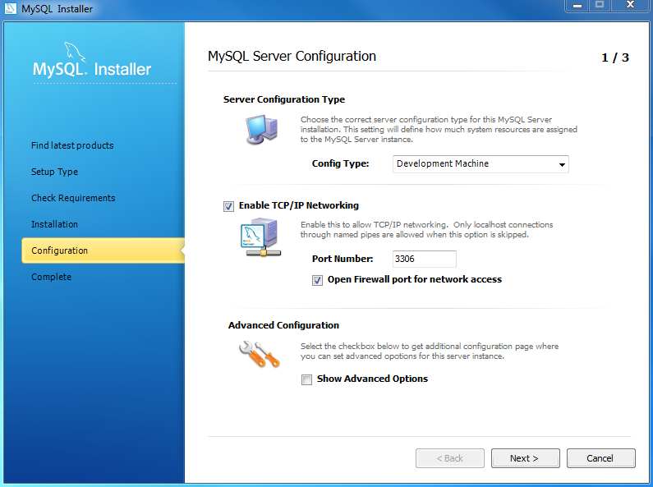  
Install MySQL Step 8.1 – MySQL Server Configuration: choose Config Type and MySQL port (3006 by default) and click Next button to continue.

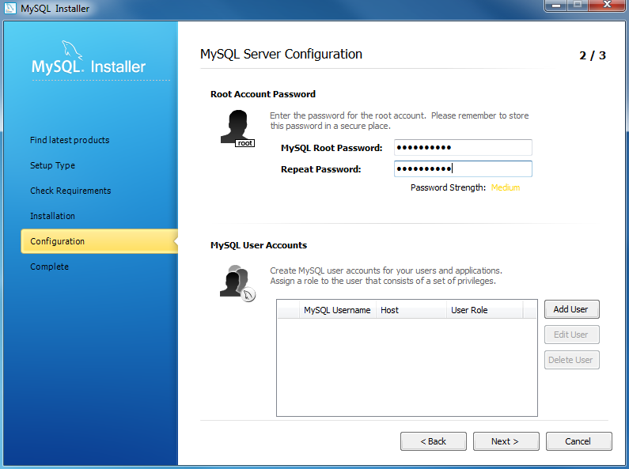  
Install MySQL Step 8.1 – MySQL Server Configuration: choose a password for the root account. Please note the password download and keep it securely if you are installing MySQL database server on a production server. If you want to add a more MySQL user, you can do it in this step.

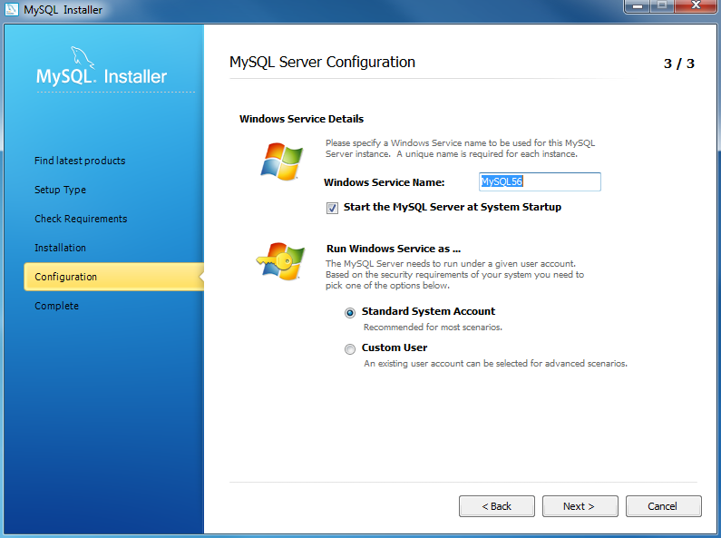  
Install MySQL Step 8.1 – MySQL Server Configuration: choose Windows service details including Windows Service Name and account type, then click Next button to continue.

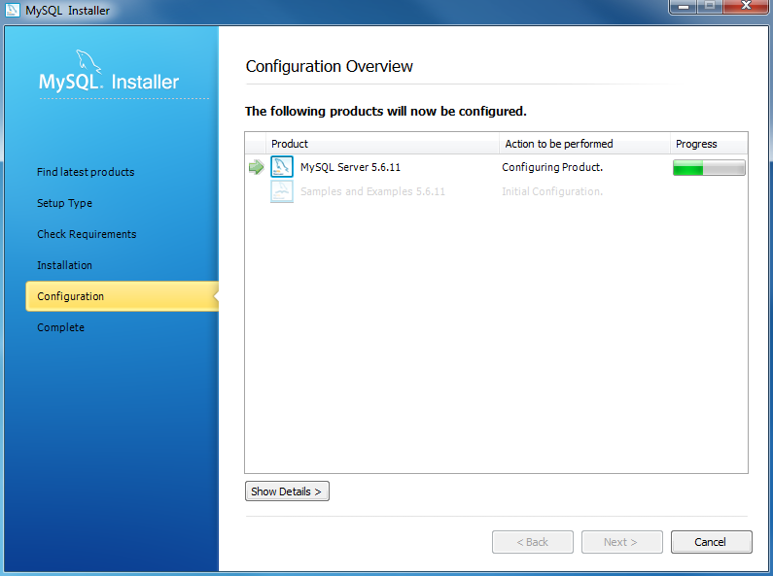  
Install MySQL Step 8.1 – MySQL Server Configuration – In Progress: MySQL Installer is configuring MySQL database server. Wait until it is done and click the Next button to continue.

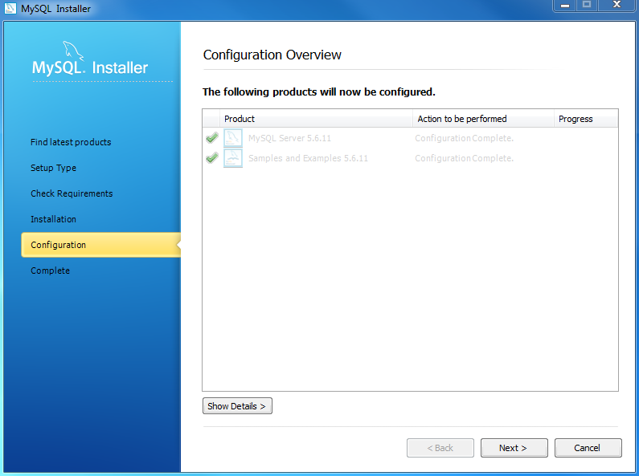  
Install MySQL Step 8.1 – MySQL Server Configuration – Done. Click the Next button to continue.

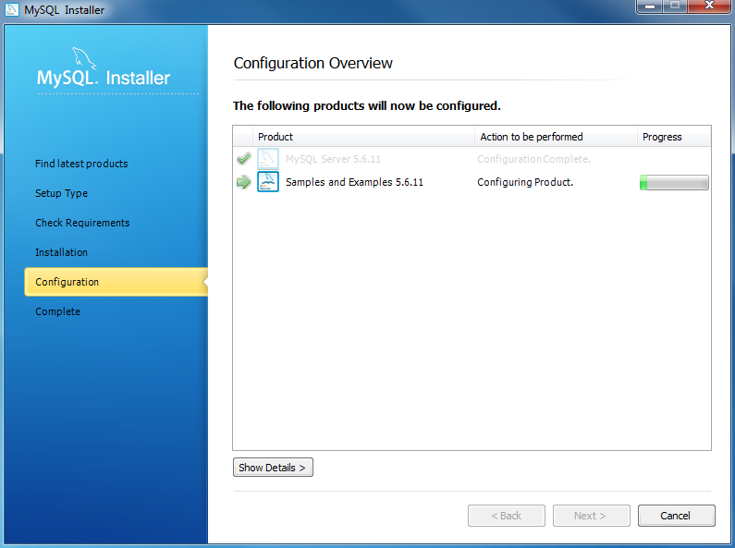  
Install MySQL Step 8.2 – Configuration Overview: MySQL Installer installs sample databases and sample models.

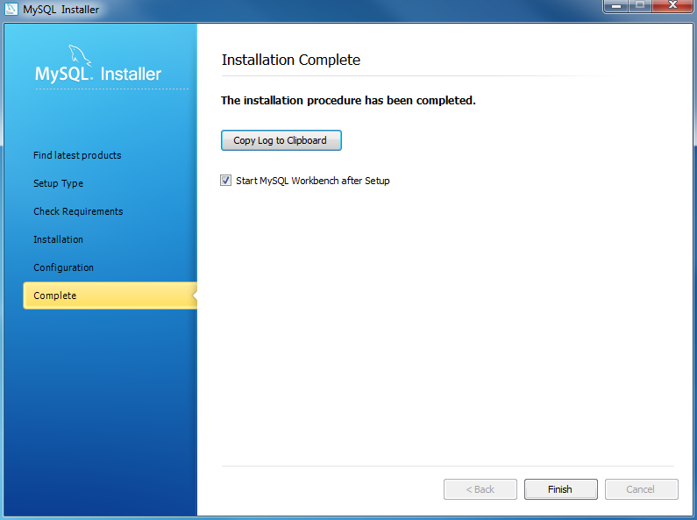

Install MySQL Step 9 – Installation Completes: the installation completes. Click the **Finish** button to close the installation wizard and launch the MySQL Workbench.